**SOFTWARE TESTING - CA1**

**QUESTION 1**

**CODE:**

package com.demo.CA1;

import org.openqa.selenium.By;

import org.openqa.selenium.WebDriver;

import org.openqa.selenium.chrome.ChromeDriver;

import org.openqa.selenium.chrome.ChromeOptions;

import io.github.bonigarcia.wdm.WebDriverManager;

public class Qn1 {

public static void main(String[] args) throws InterruptedException {

// **TODO** Auto-generated method stub

ChromeOptions co = new ChromeOptions();

co.addArguments("--remote-allow-origins=*");

WebDriverManager.*chromedriver*().setup();

WebDriver driver = new ChromeDriver(co);

driver.get("https://www.amazon.in/Adidas-Unisex-Black-Speedportal-4-Football/dp/B09N3LGGJX/ref=sr_1_3_sspa?keywords=football%2Bshoes&qid=1683195840&sr=8-3-spons&sp_csd=d2lkZ2V0TmFtZT1zcF9hdGY&th=1&psc=1");

driver.manage().window().maximize();

String title = driver.getTitle();

String etitle = "Buy Adidas Mens X Speedportal.4 FxG CBLACK/Solred/SGREEN Football Shoe - 11 UK (GW8493) at Amazon.in";

System.***out***.println(title);

if(title.equals(etitle)) {

System.***out***.println("Title is matched");

}

else {

System.***out***.println("Title Mismatched");

}

driver.findElement(By.*xpath*("//*[@id=\"add-to-cart-button\"]")).click();

Thread.*sleep*(3000);

Boolean present = driver.findElement(By.*xpath*("//*[@id=\"NATC_SMART_WAGON_CONF_MSG_SUCCESS\"]/div/div/i")).isDisplayed();

System.***out***.println("Is item added to cart:" + present);

driver.get("https://www.amazon.in/gp/cart/view.html/ref=dp_atch_dss_cart?");

Thread.*sleep*(3000);

driver.findElement(By.*xpath*("//*[@id=\"a-autoid-0-announce\"]")).click();

driver.findElement(By.*xpath*("//*[@id=\"quantity_2\"]")).click();

String Txt = driver.findElement(By.*className*("a-dropdown-prompt")).getAttribute("innerHTML");

String OriTxt = "2";

if(Txt.equals(OriTxt)) {

System.***out***.println("Updated successfully");

}

else {

System.***out***.println("Something went wrong!!!");

}

Thread.*sleep*(3000);

driver.findElement(By.*xpath*("//*[@name=\"proceedToRetailCheckout\"] ")).click();

driver.findElement(By.*xpath*("//*[@id=\"ap_email\"]")).sendKeys("8867674540");

driver.findElement(By.*xpath*("//*[@id=\"continue\"]")).click();

Thread.*sleep*(3000);

driver.findElement(By.*xpath*("//*[@id=\"ap_password\"]")).sendKeys("abcd123");

driver.findElement(By.*xpath*("//*[@id=\"signInSubmit\"]")).click();

Thread.*sleep*(3000);

String Checkout = driver.findElement(By.*xpath*("//*[@id=\"header\"]/div/div[3]/h1")).getText();

if(Checkout.equals("Checkout")) {

System.***out***.println("Checkout page is displayed successfully");

}

else {

System.***out***.println("Something went wrong!!!");

}

Thread.*sleep*(3000);

String Total = driver.findElement(By.*xpath*("//*[@id=\"subtotals-marketplace-table\"]/tbody/tr[4]/td[2]")).getText();

System.***out***.println("The calculated accurate total cost is : " +Total);

driver.get("https://www.amazon.in/gp/cart/view.html/ref=dp_atch_dss_cart?");

driver.findElement(By.*xpath*("//*[@value=\"Delete\"]")).click();

Thread.*sleep*(3000);

String removeText = driver.findElement(By.*xpath*("//*[@id=\"sc-active-cart\"]/div/div[1]/div/h1")).getText();

String extext = "Your Amazon Cart is empty.";

if(removeText.equals(extext)) {

System.***out***.println("Product is removed");

}

driver.close();

}

}

**OUTPUT:**

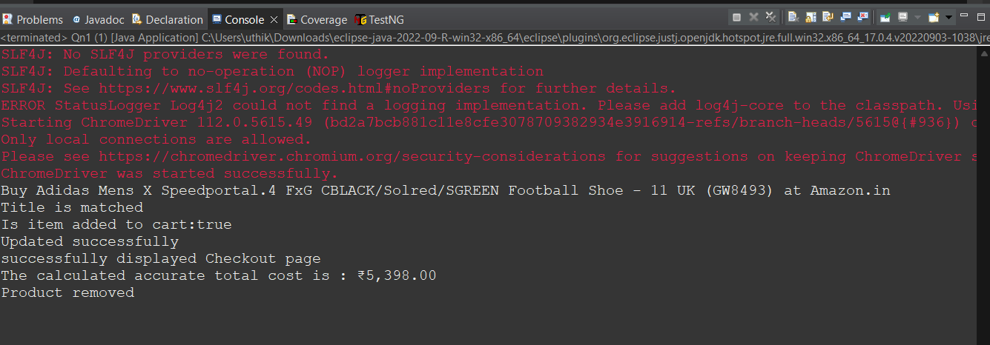

**QUESTION 2**

**CODE:**

package com.demo.CA1;

import org.openqa.selenium.By;

import org.openqa.selenium.WebDriver;

import org.openqa.selenium.WebElement;

import org.openqa.selenium.chrome.ChromeDriver;

import org.openqa.selenium.chrome.ChromeOptions;

import io.github.bonigarcia.wdm.WebDriverManager;

public class Qn2 {

public static void main(String[] args) throws InterruptedException {

// **TODO** Auto-generated method stub

ChromeOptions co=new ChromeOptions();

co.addArguments ("--remote-allow-origins=*");

WebDriverManager.*chromedriver*().setup ();

WebDriver driver=new ChromeDriver(co);

driver.get ("https://www.amazon.in/");

driver.manage().window().maximize() ;

String currentTitle=driver.getTitle();

System.***out***.println(currentTitle);

String expectedTitle="Online Shopping site in India: Shop Online for Mobiles, Books, Watches, Shoes and More - Amazon.in";

if(currentTitle.equals(expectedTitle)) {

System.***out***.println("Title Matched");

}

else {

System.***out***.println("Title not Matched");

}

WebElement txtBoxl=driver.findElement(By.*xpath*("//*[@id=\"twotabsearchtextbox\"]"));

txtBoxl.sendKeys("iphone");

driver.findElement(By.*xpath*("//*[@id=\"nav-search-submit-button\"]")).click();

String txt1=driver.findElement(By.*xpath*("//*[@id=\"search\"]/div[1]/div[1]/div/span[1]/div[1]/div[3]/div/div/div/div/div/div/div/div[2]/div/div/div[1]/h2")).getText();

System.***out***.println(txt1);

String txt2=driver.findElement(By.*xpath*("//*[@id=\"search\"]/div[1]/div[1]/div/span[1]/div[1]/div[4]/div/div/div/div/div/div/div/div[2]/div/div/div[1]/h2")).getText();

System.***out***.println(txt2);

String txt3=driver.findElement(By.*xpath*("//*[@id=\"search\"]/div[1]/div[1]/div/span[1]/div[1]/div[5]/div/div/div/div/div/div[2]/div/div/div[1]/h2")).getText();

System.***out***.println(txt3);

String txt4=driver.findElement(By.*xpath*("//*[@id=\"search\"]/div[1]/div[1]/div/span[1]/div[1]/div[6]/div/div/div/div/div/div[2]/div/div/div[1]/h2")).getText();

System.***out***.println(txt4);

String txt5=driver.findElement(By.*xpath*("//*[@id=\"search\"]/div[1]/div[1]/div/span[1]/div[1]/div[7]/div/div/div/div/div/div[2]/div/div/div[1]/h2")).getText();

System.***out***.println(txt5);

Thread.*sleep*(3000);

//filter

driver.findElement(By.*xpath*("//*[@id=\"a-autoid-0\"]/span")).click();

Thread.*sleep*(2000);

driver.findElement(By.*xpath*("//*[@id=\"s-result-sort-select_2\"]")).click();

System.***out***.println("Sort by Price is Applied");

}

}

**OUTPUT:**

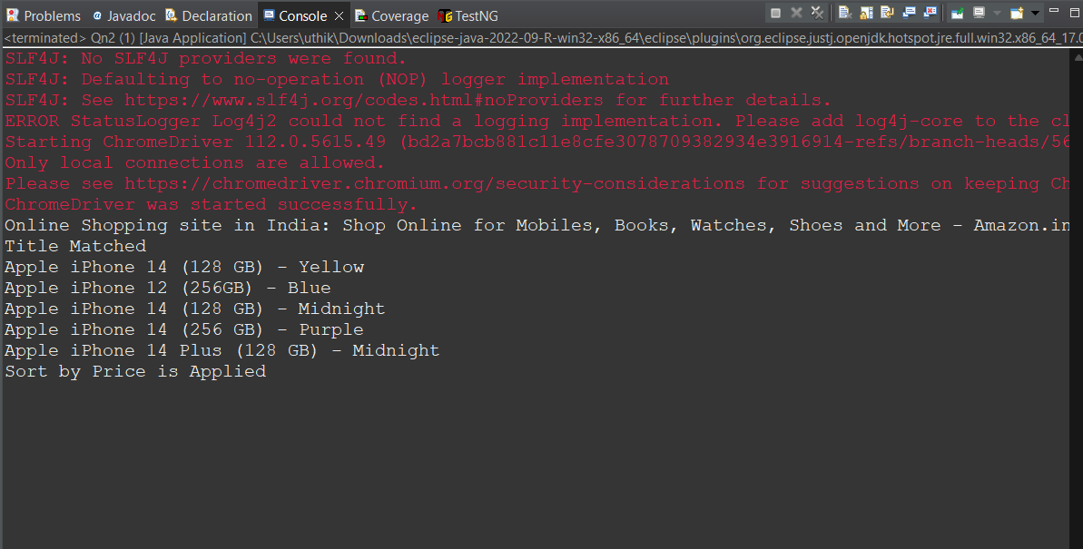

**QUESTION 3**

**CODE:**

**OUTPUT:**

package com.demo.CA1;

import org.openqa.selenium.By;

import org.openqa.selenium.WebDriver;

import org.openqa.selenium.WebElement;

import org.openqa.selenium.chrome.ChromeDriver;

import org.openqa.selenium.chrome.ChromeOptions;

import io.github.bonigarcia.wdm.WebDriverManager;

public class Qn3 {

public static void main(String[] args) {

// **TODO** Auto-generated method stub

ChromeOptions co=new ChromeOptions();

co.addArguments ("--remote-allow-origins=*");

WebDriverManager.*chromedriver*().setup ();

WebDriver driver=new ChromeDriver(co);

driver.get ("https://www.amazon.in/");

driver.manage().window().maximize() ;

String currentTitle=driver.getTitle();

System.***out***.println(currentTitle);

String expectedTitle="Online Shopping site in India: Shop Online for Mobiles, Books, Watches, Shoes and More - Amazon.in";

if(currentTitle.equals(expectedTitle)) {

System.***out***.println("Title Matched");

}

else {

System.***out***.println("Title not Matched");

}

driver.findElement(By.*xpath*("//*[@id=\"nav-link-accountList\"]")).click();

WebElement txtBoxl=driver.findElement(By.*xpath*("//*[@id=\"ap_email\"]"));

txtBoxl.sendKeys("8065356876");

driver.findElement(By.*xpath*("//*[@id=\"continue\"]")).click();

WebElement txtBox2=driver.findElement(By.*xpath*("//*[@id=\"ap_password\"]"));

txtBox2.sendKeys("abc123");

driver.findElement(By.*xpath*("//*[@id=\"signInSubmit\"]")).click();

driver.findElement(By.*xpath*("//*[@id=\"nav-link-accountList\"]")).click();

driver.findElement(By.*xpath*("//*[@id=\"a-page\"]/div[2]/div/div[2]/div[1]/a/div/div")).click();

String Total = driver.findElement(By.*xpath*("//*[@id=\"a-page\"]/section/div/div[2]/div[1]/h1")).getText();

if(Total.equals("Your Orders")) {

System.***out***.print("Order details Viewed");

}

else {

System.***out***.println("Error");

}

}

}

